Intro to Unreal Engine - Part Three
  - Power Ups, Collectibles, and Public Variables

Overview
This is the third part of our five-part introduction to Unreal Engine. When the player reaches this level, they will have navigated our parkour challenge and defeated our moving-island mayhem. Inconceivable! The player is getting closer to finding the key and unlocking the secret door. In this activity, you will be adding a power-up that allows the player to reach platforms that are much higher than they can reach right now. We will also look at the code that makes this power-up work, giving you a chance to make changes to improve the gameplay. Then you will add coin pickups to entice the player to explore new areas of the map.
This module contains screenshot from Unreal Engine 4. Although the look and feel of the UI has been updated for Unreal Engine 5, you should still be able to follow these screenshots while working through this tutorial. Please alert your instructor if you come across instructions or screenshots that need to be updated.

Learning Outcomes
By the end of this module, you should be able to:
- Explain how Unreal Engine assets can be customized using public variables.
- Open the Event Graph associated with an asset to view the Blueprint code.
- Read Blueprint code by following the flow of the node and wire logic.

Let’s Play
The use of collectible objects, such as coins, can be used to track progress and/or keep score. Coins can also be used to guide the player through certain areas and to tempt them into difficult to reach areas. These items could be optional. Collectibles can also be required, like a power-up that temporarily allows the player to get a jump-boost to help them reach an otherwise unreachable location.
Some games also require a player to complete a quest by collecting a specific item, such as a key that will be used later to open a locked door. This game mechanic will be covered in part 4.
Let’s start by playing the game from our current large floating island. Let’s navigate there by clicking the Viewport and pressing the 3 key to move to our camera 3 bookmark. Make sure the Current Camera Location option is selected by navigating to the Play button options and pressing Play. Notice that the next floating island is too high to reach by jumping (Figure 001).
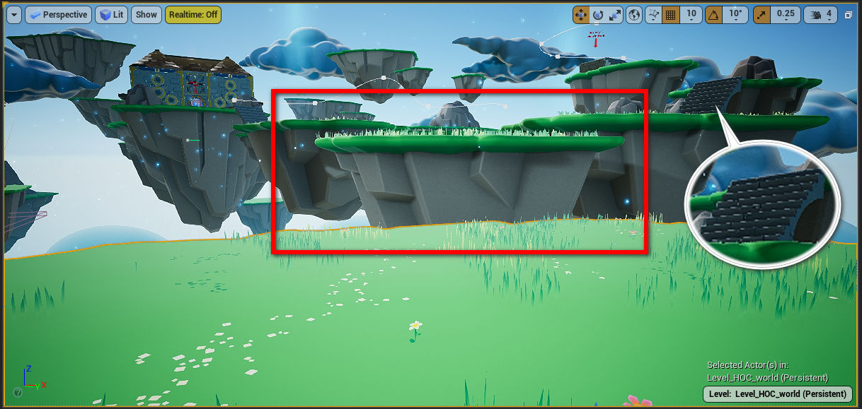
Figure 001 – The Next Floating Island The Player Needs To Reach.

Jump-Boost Pickup
We could create additional platforms, or we could animate a moving platform, but we have already completed that in previous activities. Therefore, in this activity we are going to work with a simple power-up that changes the Character Movement variables.
For our purposes, think of a variable as a value, or a number, that can be changed at any time during the game to achieve the desired result. In our case, we want to temporarily change the jump velocity. Simply put, we want to jump higher!
🤖 TECHNICAL JARGON DEFINED
A variable can be any type of information that is saved in a way that it can be read and modified at any time. Common uses of variables include tracking the score and the time in a game. You will be using variables to keep track of collected items and the effect of power-ups.
You can scout out the platform we want the player to reach next by using the camera 4 bookmark, but return to the camera 3 bookmark to place the jump boost. Next, in the Content Browser navigate to Content > Hour_of_Code > Blueprints and drag the BP_jumpBoost Blueprint into your Level onto the floating island where the player can reach it.
Power-ups are special. Let’s make them appear to be floating above the ground. After placing your power-up in the world, press the W key to enable the Select and translate (move) gizmo. Grab the blue arrow and drag the power-up just slightly above the ground.
To recap (Figure 002):
- Use camera bookmark 4 to visit to the island you want the player to reach next, and then return to the island where you need to place the jump boost by using bookmark 3.
- Place the BP_jumpBoost near the edge of the island closest to the island you need the player to reach next.
- Raise the jump boost a little above the ground using the move gizmo.
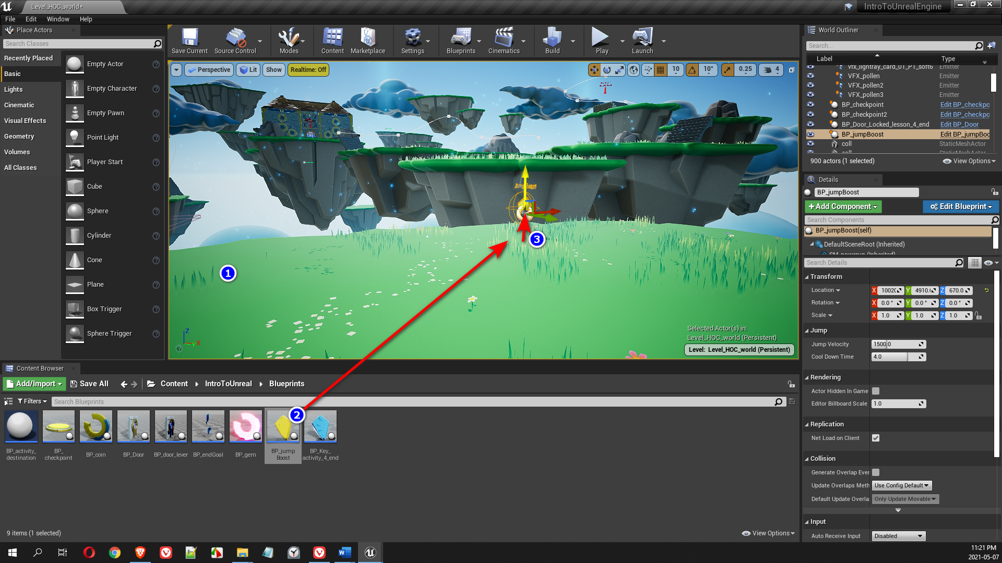
Figure 002 – Placing the jump boost collectible on the part 3 starting island.
Now play the game and walk slowly towards the checkpoint to avoid falling off the edge. Then walk over the jump boost. Now you can jump high enough to reach the next floating island. This power-up is temporary so be quick, it will only last 4 seconds! If you die, don’t worry the power-up will respawn after 4 seconds, giving you another chance. (Figure 003)
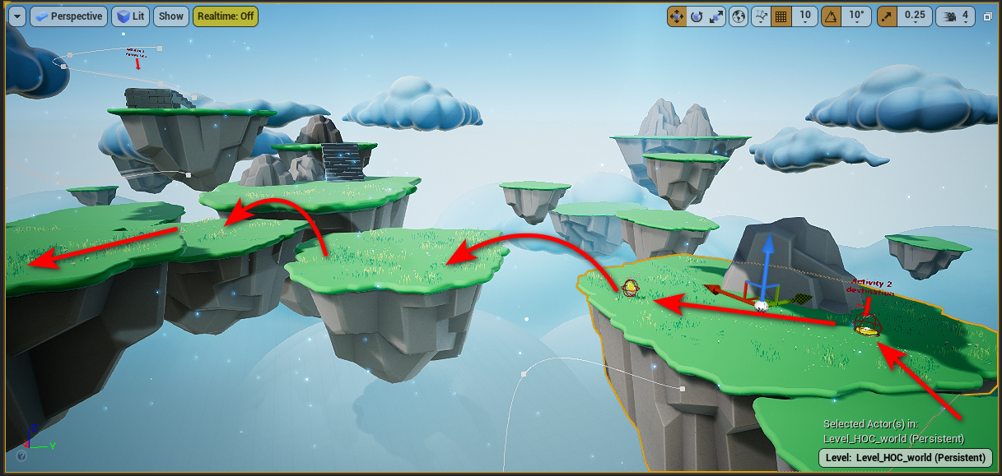
Figure 003 – The Path Our Player Will Take Using the Jump Boost.
🖖 LENDING A HELPFUL HAND
Remember to Save All your work often. Unreal Engine can crash taking your unsaved work down with it.

Customizing the Jump Boost Power-Ups
Now that you’ve had a chance to see how this works. Let’s play with some of the Public Variables. Select the BP_jumpBoost in the Level, then look in the Details panel. These Variables can be found under the Jump section (Figure 004). Simply click and drag on these sliders to change their value, or you can also type a value in the field. These specific Variables store a type of number called a Float. A simple way to think about a Float is that it’s a number that contains a decimal point.
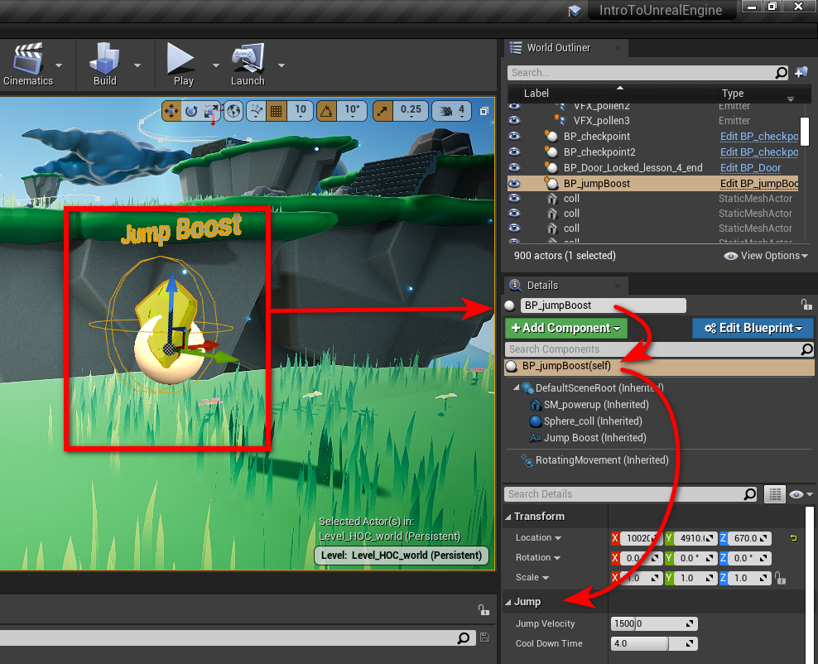
Figure 004 – The Jump Variables
By changing the Jump Velocity, you can make the character jump higher or reduce how high the character can jump. The Cool Down Time changes how long the player will have the power-up in addition to when it will respawn.
🤝 PRO TIP FOR THE WIN
The little arrows next to the sliders enable you to reset them to their default values.
GAME DESIGN FUN
Each instance of BP_jumpBoost you place in the Level can be set up to have different values. Try setting a few of these up in your level and see what it takes to get the player to jump back to the second tunnel.

Opening the Jump Boost Code
Next, let’s look under the hood to see what is happening. Select the BP_jumpBoost in the Level and press Ctrl + E, or double click it in the Content Browser to open the Blueprint Editor. You can maximize the Blueprint Editor if it isn’t already maximized by default when it was opened.

Explore the Variables
Navigate to the Event Graph tab. Then locate the Variables section on the left-hand side of the interface and open the drop-down for the Jump variables category (Figure 005).
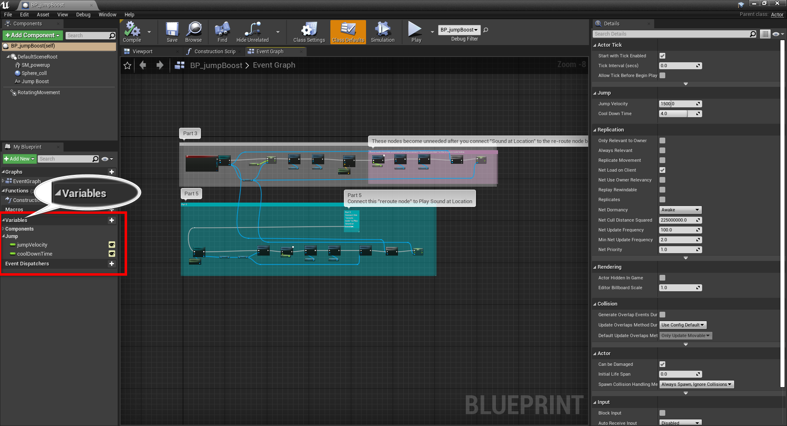
Figure 005 – The Jump Boost Public Variables
In the variables area you will see that the jumpVelocity and coolDownTime have little open eye icons next to them. This is what makes them Public Variables.
Public variables are handy for game designers because they allow programmers and artists to make changes to the code’s behaviour without having to open the Blueprint. This makes for faster iteration when playtesting, which you experienced when modifying the jumpVelocity and coolDownTime of the jump boost power-up in your level.
📝 NOTA BENE
By convention, in Unreal we use what is called camelCase notation for our variable names. This means we start our variable names with a lowercase letter and subsequent words in the name are capitalized. No spaces are used in our variable names. When displayed in the Event Graph, the first letter is capitalized, and spaces are added before each capital. Thus jumpVelocity is displayed as Jump Velocity. (Figure 006)
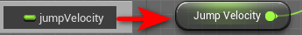
Figure 006 – Variable name vs Node name.

Explore the Viewport
Switch to the viewport tab (Figure 007) to inspect the game objects that make up this object.
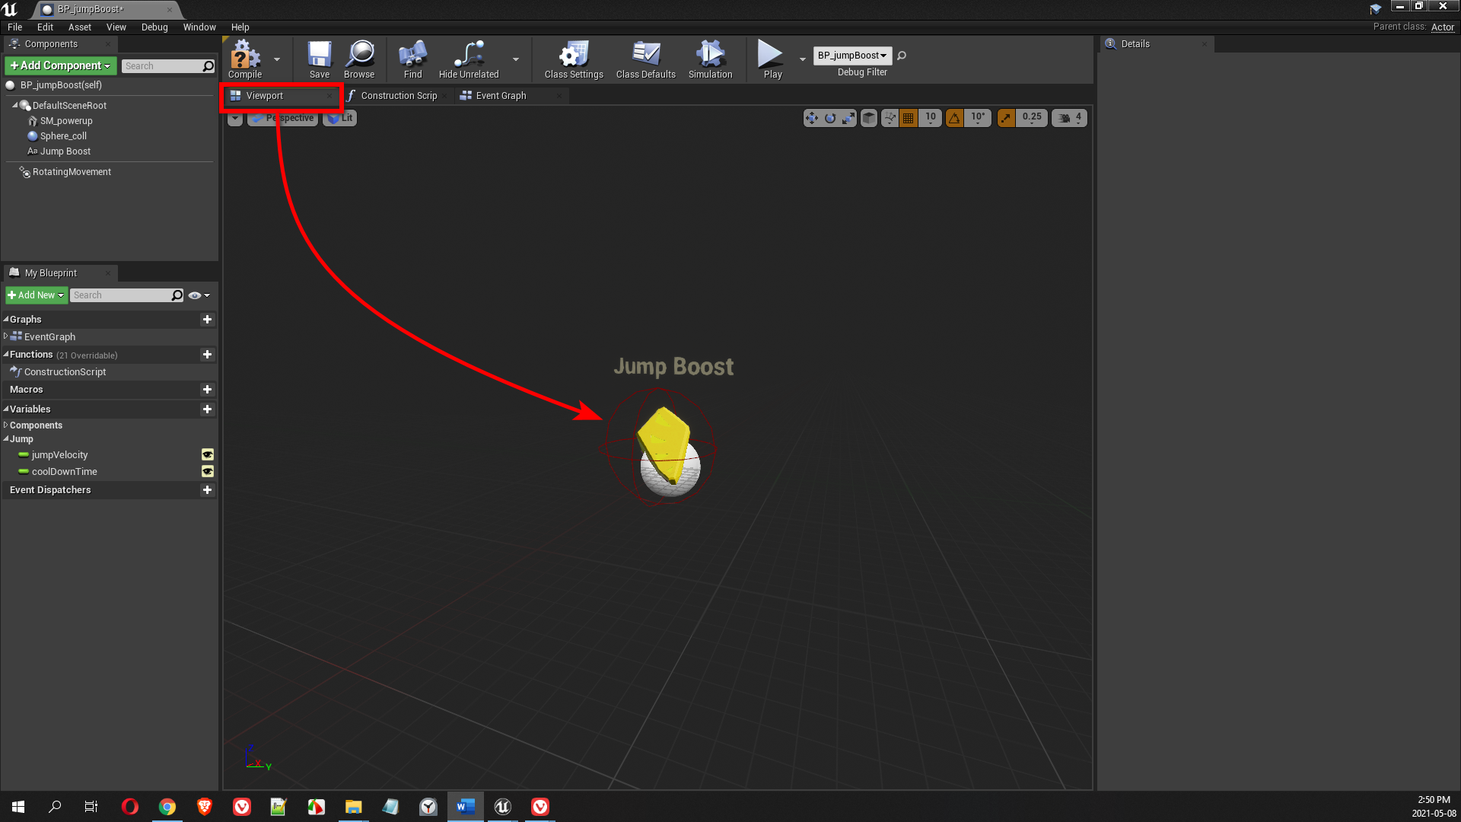
Figure 007 – The Jump Boost Viewport
The Jump Boost is comprised of 4 objects - the DefaultSceneRoot, the SM_powerup mesh, the Sphere_coll collider, and the Jump Boost text string (Figure 008).
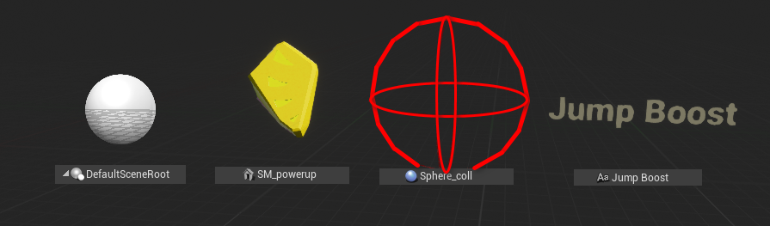
Figure 008 – The Components That Make Up The Jump Boost

Explore the Event Graph
Select the Event Graph tab (Figure 009) and take a look at the Blueprints code - you can now inspect the code modules that make this object work.
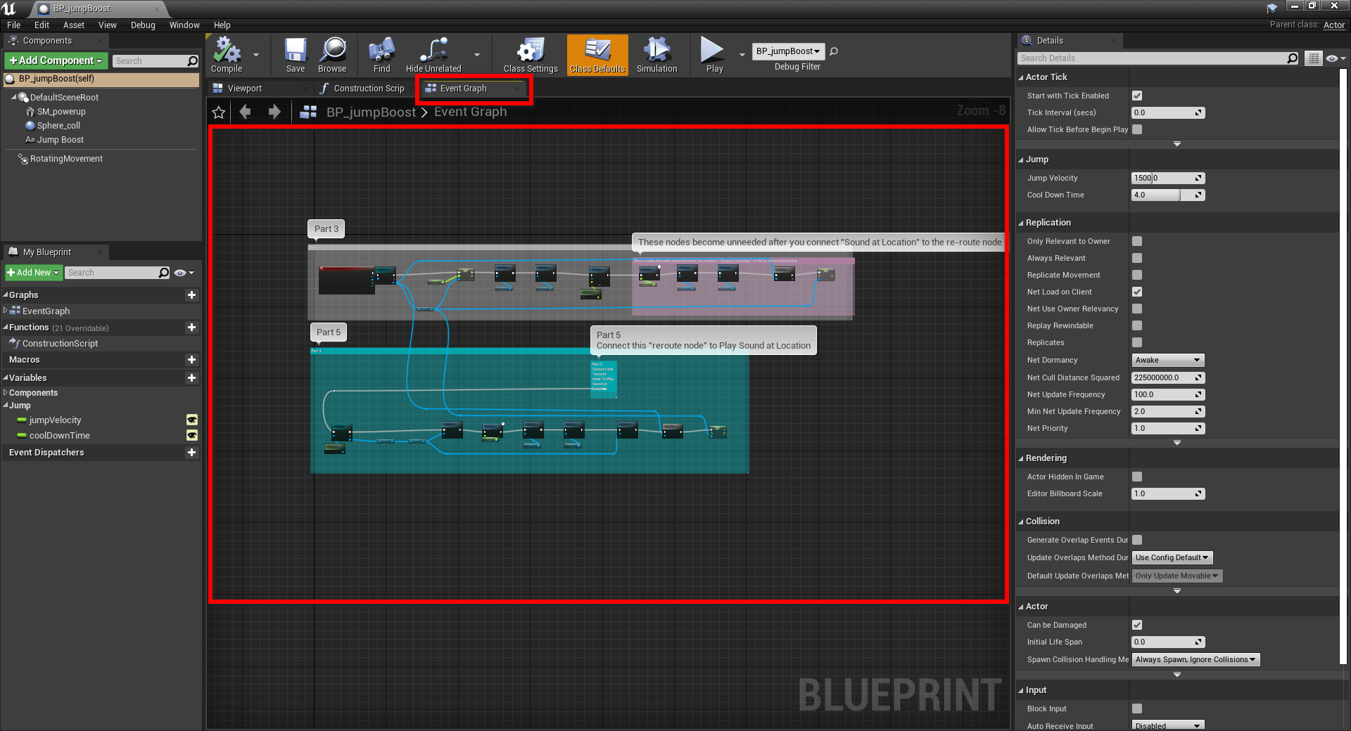
Figure 009 – The Event Graph tab in the jump boost Blueprint
📝 NOTA BENE
You may notice a blue section at the bottom of the Event Graph labelled “Part 5”. This can be ignored as we will be addressing this in module 5 of this tutorial series. (Figure 009)

Blueprint Basics
Blueprints are blocks connected with virtual wires. The points where wires connect to blocks are called Pins. Let’s review some important concepts used in Blueprints.
- The white pins are called Execution Pins. Think of this as the power supply and the sequence of events. Blocks will run in the order they are connected by white wires.
- Each block can have pins on the left and right sides. Pins on the left side are used for providing the inputs that the block will need to execute. Pins on the right side are outputs that can send the result of the execution to another action or save it to a variable.
- To connect wires, click and drag from one pin onto the destination pin, and release the mouse button.
- Unreal Engine is an event-driven environment. You’ll notice that the first block is activated by a specific event. That means this code sits and waits for something to happen, like the player touching a power-up, which triggers the execution of that code sequence. In this case, when something begins overlapping this object’s Sphere_coll collider, our Blueprint code starts executing.
- Blueprints make good use of color-coding to help quickly identify block types and compatible connections. You’ll notice that only the same-colored pins are connected together.
🖖 LENDING A HELPFUL HAND
Blueprints make use of color-coding to help you quickly identify block types and compatible connections. You’ll notice that only the same-colored pins can be connected together. In the Part 3 Blueprint, Actors and objects are blue, while floats (decimal numbers) are green. Other common types are integers (sea green), booleans (red), vectors (gold) and text strings (magenta).

Explore the Jump Boost Code
Now, let’s examine the code closer. Using the scroll wheel on your mouse, zoom in to the left-hand side of the Part 3 section. Use the right mouse button to pan within the Blueprint Editor Graph. We will break the code into 7 sections to help make this more manageable to understand.
The seven outlined sections of Blueprint code explained:
- When any object overlaps the Sphere collision (Sphere_coll) our code starts to execute a call (cast) to the Character (BP_HourOfCode_Character). If the overlapping object is indeed the character, the cast will succeed and code execution will continue. If the overlapping object is not the character, the code execution stops. (Figure 010)
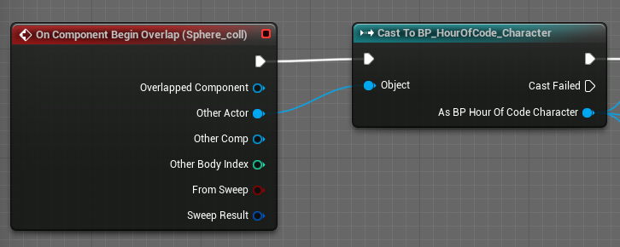
Figure 010 – The code is triggered when the player touches the jump boost collision sphere.
- Using the validated reference to the “BP_HourOfCode_Character” the Jump Z Velocity value of the Character Movement is set to the Jump Velocity variable value chosen by you, the designer (Figure 011).
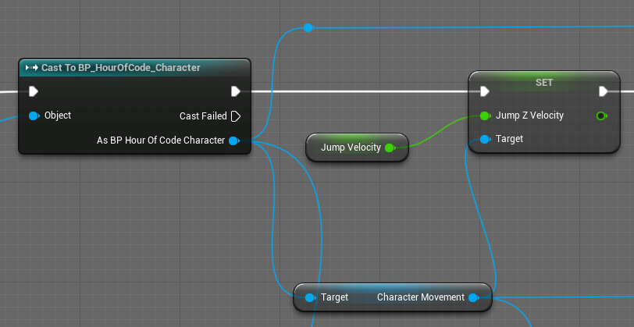
Figure 011 – Setting a new value for the player’s jump velocity.
- The next two nodes turn off the visibility of the powerup and disable the collider. The powerup is still in the game but it can no longer be interacted with. (Figure 012).
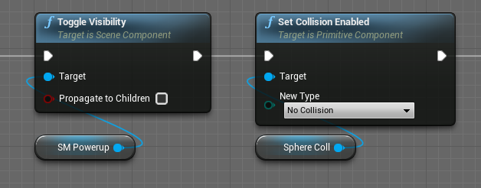
Figure 012 – Hiding the jump boost after it has been collected.
- The next nodes play a sound at the powerup’s location. (Figure 013).
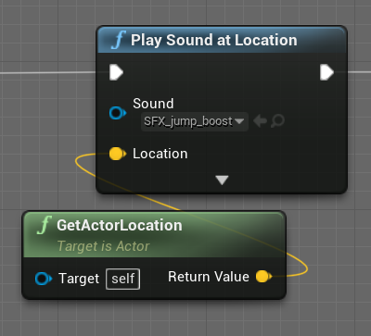
Figure 013 – Play a sound when the jump boost is collected.
- Next, there is a delay set by the value of the Cool Down Time variable. After this delay, the visibility of the SM_Powerup is toggled back ON, and the collision of the Sphere is re-enabled (Figure 014).
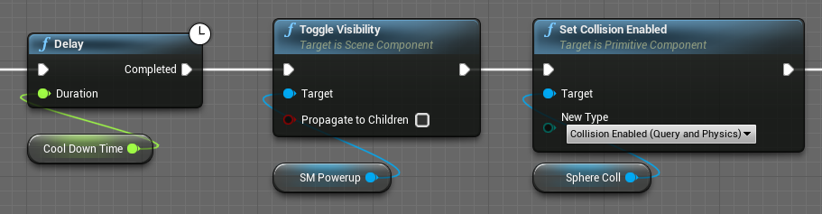
Figure 014 – Re-enable the jump boost pickup after a cool down time.
- The next node checks to see if the Character is still alive. It’s asking if the character reference from the cast in step 1 is still valid (Figure 015). If you follow the blue wire back, you will see that it leads to the Cast to BP_HourOfCode_Character node. This check is important because the next step will fail if the character has died.
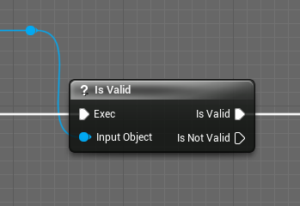
Figure 015 – Making sure the character hasn’t died.
- This last node is setting the Character’s Movement Jump Velocity back to the value it was originally (Figure 016). Again, you can follow the blue wire back to where it is connected to the character.
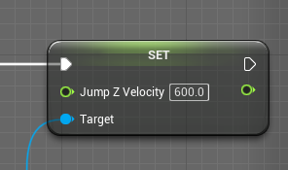
Figure 016 – Resetting the jump boost after the cool down time.

Blueprint Recap
OK, that is a lot. So, let’s recap in a single breath. This Blueprint allows the character to jump higher for a short time. When activated, the visibility and collision of the powerup are temporarily disabled so the player cannot pick it up again. As a bonus, a sound plays to let the player know they have acquired the power-up. When the jump boost expires, the power up is re-enabled so the player can collect the jump boost again and their jump speed reset.
Close the Blueprint Editor to get back to your project. Remember to Save All your work.

Coin Pickups
In this section, you will add a few coins to reward the player for reaching new places. In a later module we’ll create a heads-up display (HUD) to keep track of the number of coins collected.
Within the Blueprints folder, drag out a few copies of the BP_coin Actor and place them in your level. (You can also duplicate objects in your world by holding the ALT key then moving the object with the Move Gizmo.) You can reward players, encourage them to explore, or lead them into danger by having shiny objects lying around your level. These coins will work perfectly as a guide to a group of even more coins up above.
You’ll notice that there is another island that the player won’t be able to reach unless you give them another jump boost, so be sure to help them out (Figure 017). In part 5 we’ll be placing a secret key on this island.
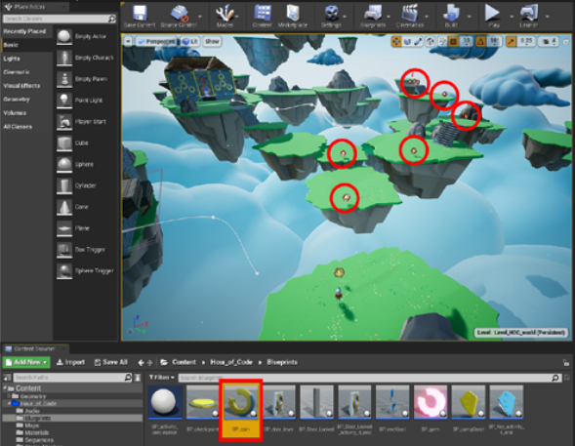
Figure 017 – Create a path of coins to guide the player.

More Level Design
As we progress deeper into our game, we now present the player with multiple options of choice. Coins and jump boosts can be used to guide the player or to reward them for exploring the level. It’s time for you to add the following items to the Level 3 area of this map.
Adding Coins – Add more coins to your level. Think about using coins to guide the player. Maybe you can try to lead the player up to the large structure in front of them? They’ll get to a locked door only to realize that they must go back to find the key.
Add Jump Boost – A jump boost is needed to make the first jump, but that should already be in place. If the player navigates to the right, then there is another jump that needs a jump boost power-up. Place this additional jump boost power-up so the player can make the jump. The island they can now reach would be a great place to put the secret key in part 5.
🖖 LENDING A HELPFUL HAND
Another reminder to Save All your work. Unreal Engine can crash taking your unsaved work down with it.

Up for a Challenge?
Open the BP_coin and see if you can figure out how it works. Why would this Blueprint cast to the Game and not to the Character? You will also notice there is a section labeled Activity 5 inside the Coin Blueprint. The Activity 5 section is where we will be hooking up the Heads-Up Display (HUD).

Play Testing
Remember to ask your peers to playtest. Watch them play, but don’t guide them or speak while they are playing. Are they following your intended path? Are they confused? Are they stuck? If your play-testers are having trouble getting to specific locations, you should try to correct it. If you’ve added too much extra complexity, it may be worthwhile to remove it. If the path is critical to the gameplay, you can work on improvements before your next play-tester attempts to try your game.

Part Three Completed!
Well done! You’ve now added jump boosts and coins to your level design repertoire. You’ve also seen how public variables can be used to tweak the properties and behaviours of actors. And you’ve spent more time reviewing how Blueprint scripting can be used to add event-driven scripts to your game.

What’s Next?
The next activity will introduce a conditional, the key item, which will allow you to unlock the door, enabling your players to complete the game.
YOUR PROGRESS
  

Further Reading
- Official Blueprint Editor Reference
- Official Blueprint Editor Viewport Guide
- Official Guide to Blueprint Variables

